<https://linuxize.com/post/how-to-install-apache-maven-on-ubuntu-20-04/>

<https://www.vogella.com/tutorials/ApacheMaven/article.html>

<https://javakeypoint.wordpress.com/2020/08/18/difference-between-mvn-clean-package-and-mvn-clean-install/>

apt update && apt install -y openjdk-11-jdk

java -version

apt update && apt install -y maven

mvn --version

https://github.com/mavrick202/spring-petclinic

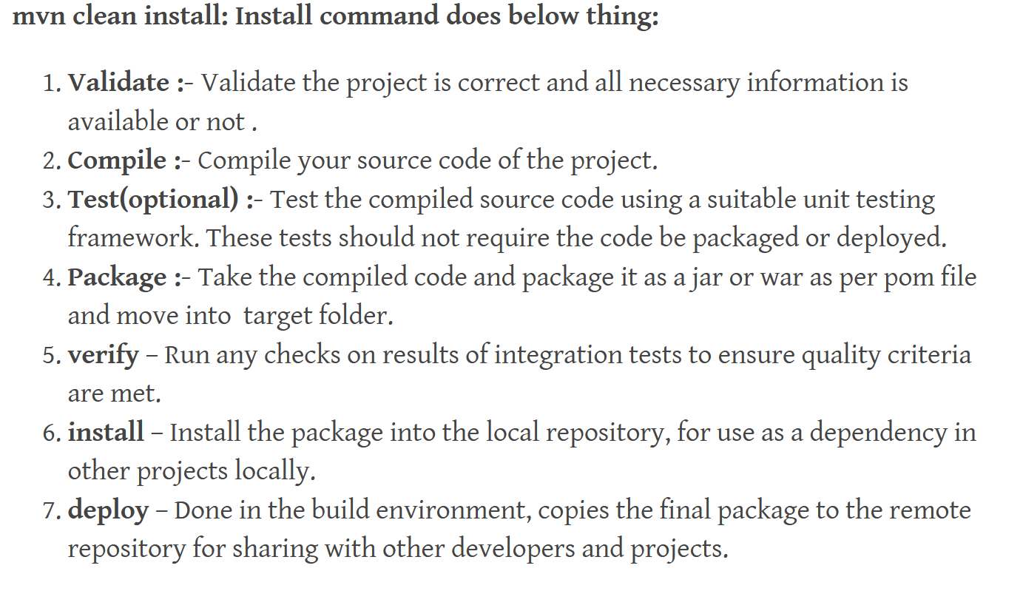

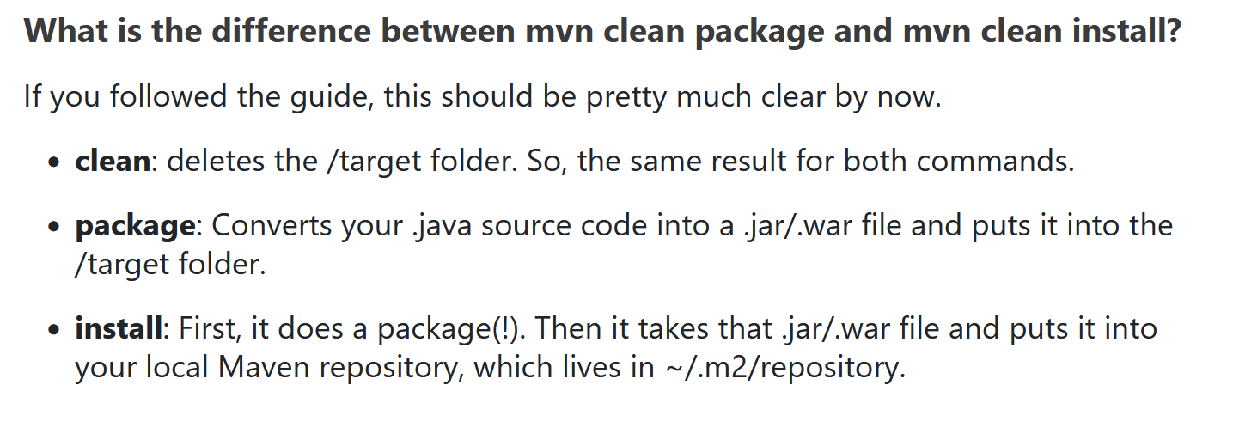

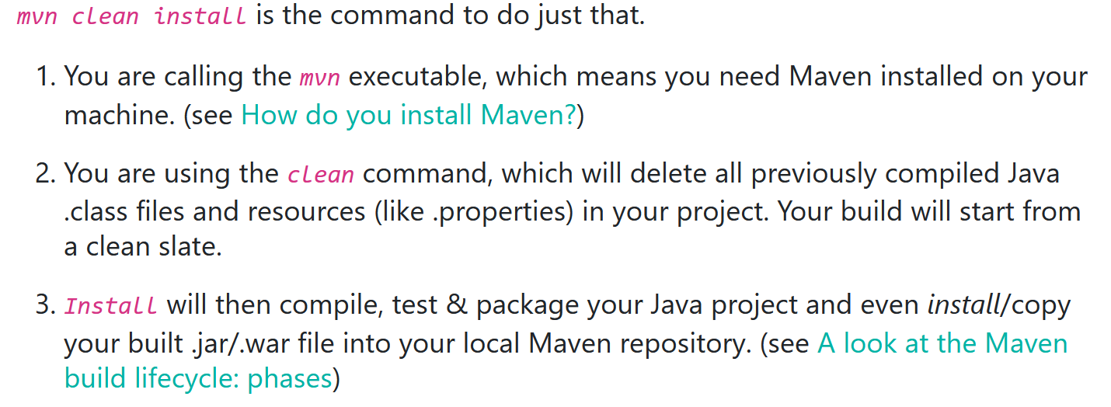

<https://github.com/spring-projects/spring-petclinic>

<https://github.com/mavrick202/spring-petclinic> - Use this for Maven Testing

Good videos on Maven: <https://www.youtube.com/watch?v=Xatr8AZLOsE>

For maven dependencies: <https://search.maven.org/>

<https://springframework.guru/spring-profiles/>

To Start a new Java Springboot Project:

<https://start.spring.io/>

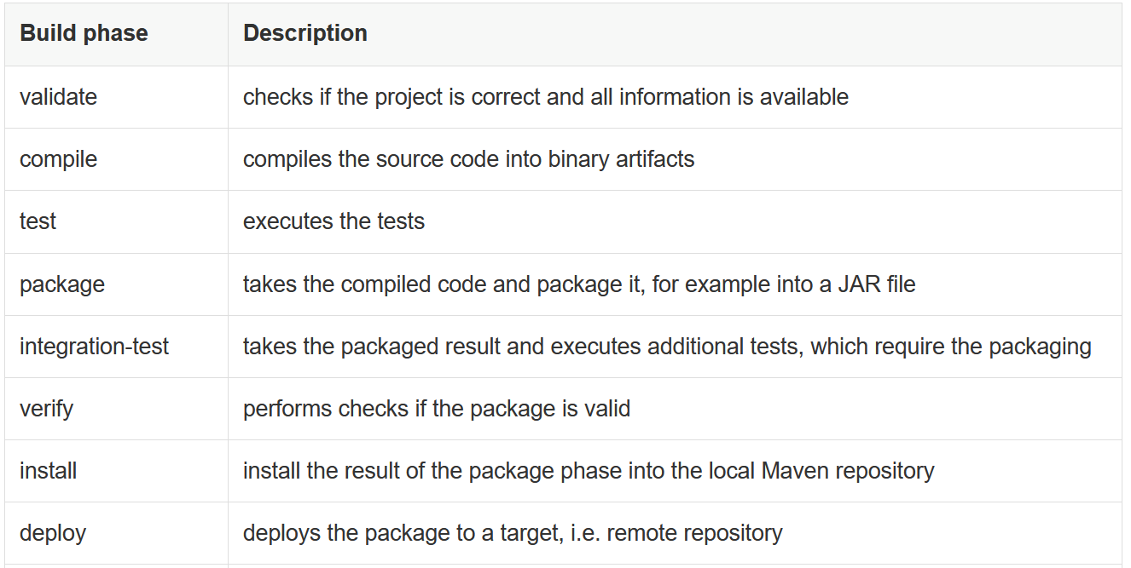

Use below step:

cd /opt

wget https://dlcdn.apache.org/maven/maven-3/3.8.4/binaries/apache-maven-3.8.4-bin.tar.gz

tar xzvf apache-maven-3.8.4-bin.tar.gz

mv apache-maven-3.8.4-bin.tar.gz maven

echo 'export M2_HOME=/opt/maven' >> ~/.bashrc

echo 'export PATH=${M2_HOME}/bin:${PATH}' >> ~/.bashrc

source ~/.bashrc

mvn –version

git clone https://github.com/jenkins-docs/simple-java-maven-app.git

mvn validate

mvn compile

mvn test

mvn package

java -jar /root/simple-java-maven-app/target/my-app-1.0-SNAPSHOT.jar

nano /root/simple-java-maven-app/src/main/java/com/mycompany/app/App.java #Add Custom data

nano /root/simple-java-maven-app/src/test/java/com/mycompany/app/AppTest.java #Add Custom data.

mvn clean

mvn clean compile

mvn clean compile test package

mvn clean compile test package verify

mvn clean compile test package verify install

mvn clean compile test package verify install deploy

mvn package -Dmaven.test.skip=true

**How to increment artifact version**

As of now everytime you run mvn clean deploy , it will create and push the package to jfrog with the same version which is 2.7.3. We can increment the version to avoid overwriting the artifacts.

<https://medium.com/javarevisited/how-to-increment-versions-for-the-maven-build-java-project-a7596cc501c2>

Add following code under the plugins:

<plugin>

<groupId>org.codehaus.mojo</groupId>

<artifactId>build-helper-maven-plugin</artifactId>

<version>3.2.0</version>

</plugin>

<plugin>

<groupId>org.codehaus.mojo</groupId>

<artifactId>versions-maven-plugin</artifactId>

<version>2.8.1</version>

</plugin>

We can set the version by running the command:

mvn versions:set -DnewVersion=1.0.0

mvn clean install deploy

mvn versions:set -DnewVersion=1.0.1

mvn clean install deploy

mvn versions:set -DnewVersion=1.0.2

mvn clean install deploy

sh "mvn versions:set -DnewVersion=Dev-1.0.${BUILD_NUMBER}"

sh "mvn package deploy"

sh "mvn versions:set -DnewVersion=Prod-${BUILD_NUMBER}"

sh "mvn package deploy"

